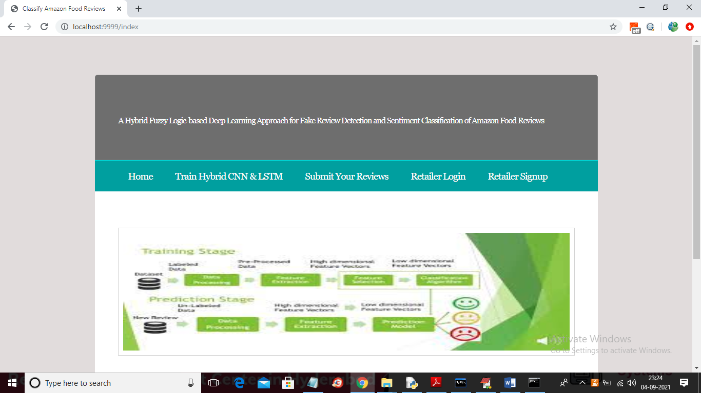

In above screen click on ‘Train Hybrid CNN & LSTM’ link to train both algorithms on ‘Amazon Food reviews’ dataset and to get below output

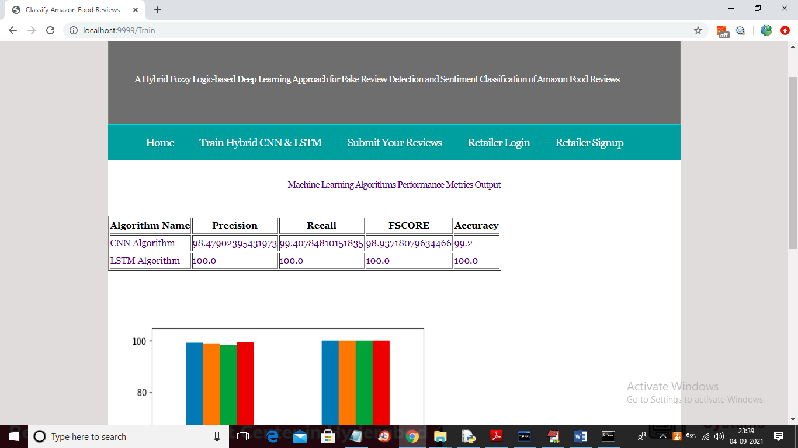

In above screen both algorithms are trained and its performance values in terms of accuracy, precision are calculated and below is the comparison graph

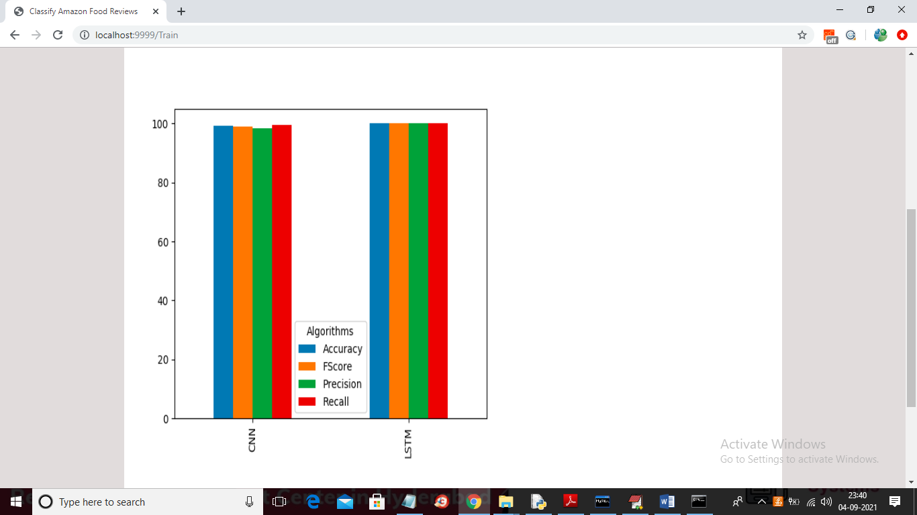

Now click on ‘Submit Your Reviews’ link to submit reviews

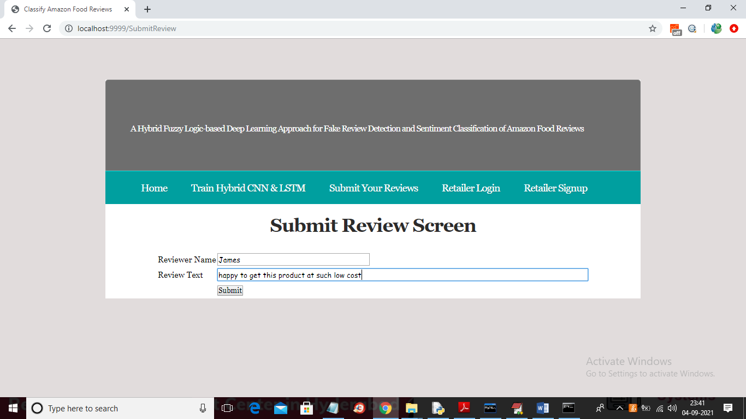

In above screen I entered some review and now click on ‘Submit’ button to get below prediction result

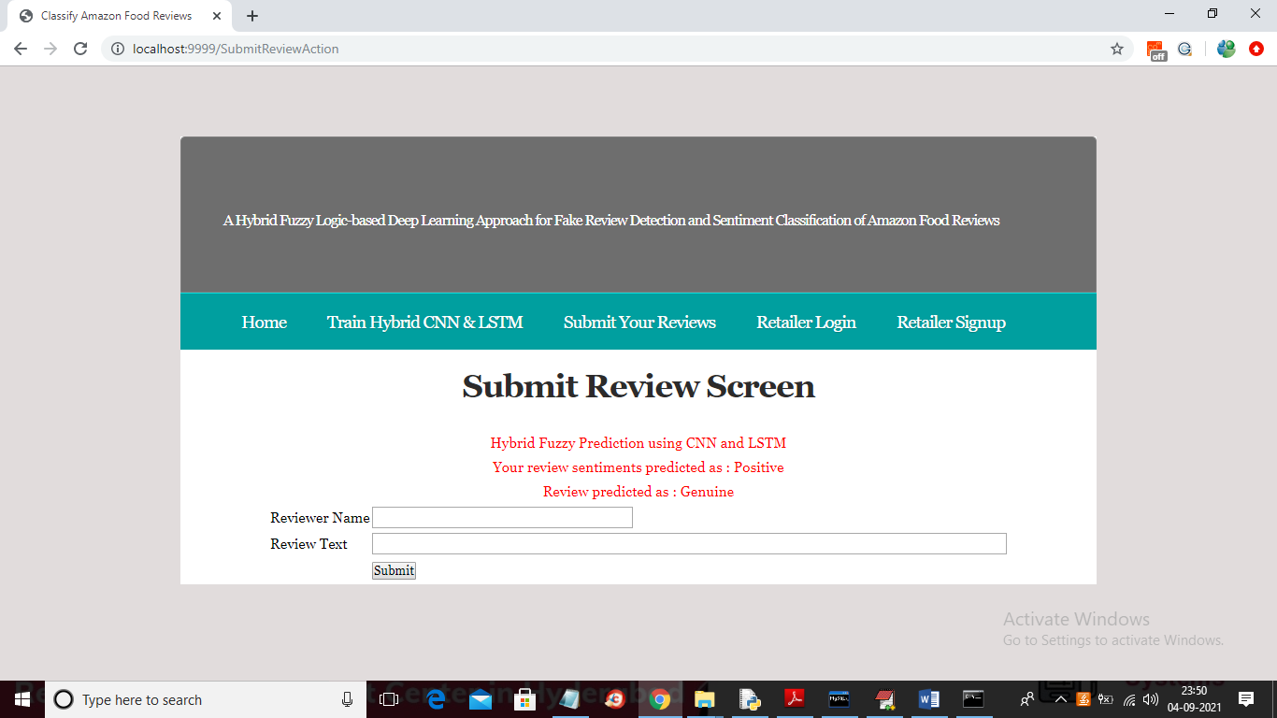

In above screen you can see given review is predicted as ‘POSITIVE’ and ‘GENUINE’ and similarly you can try other reviews and now test other review

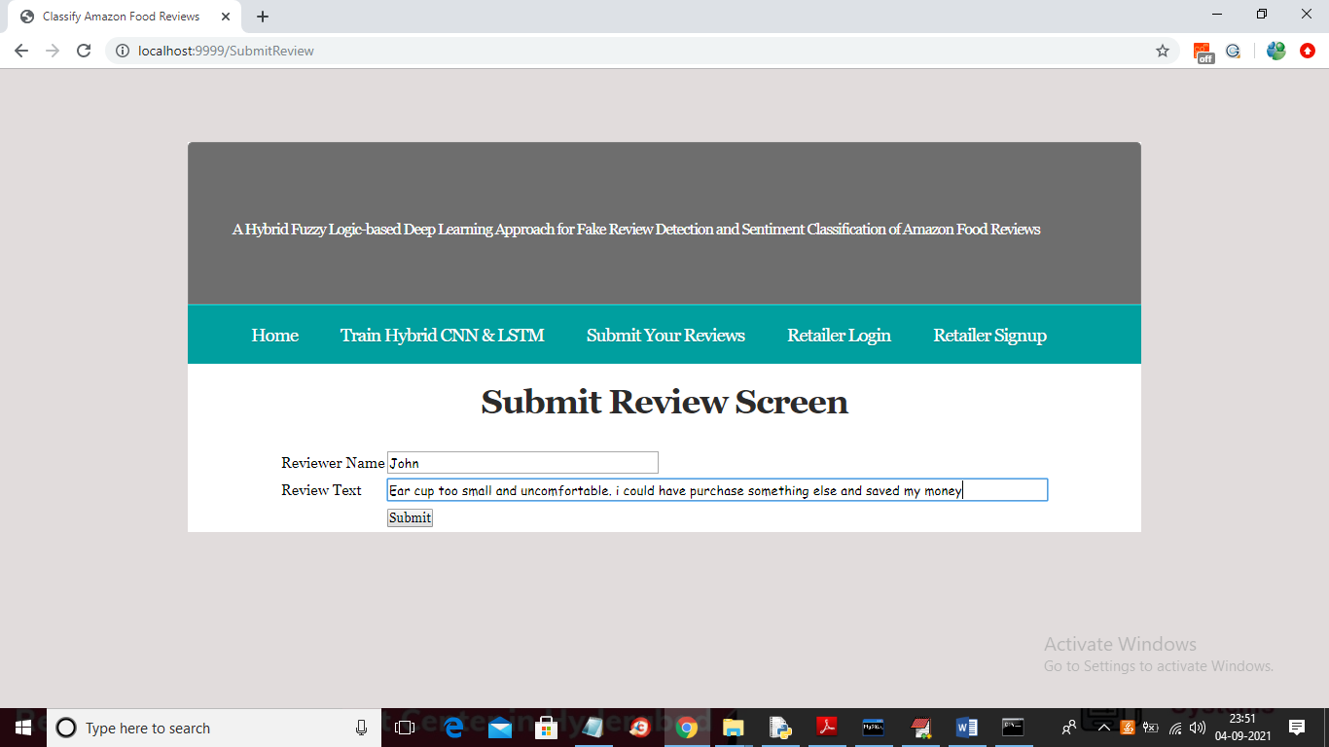

For above review below is the result

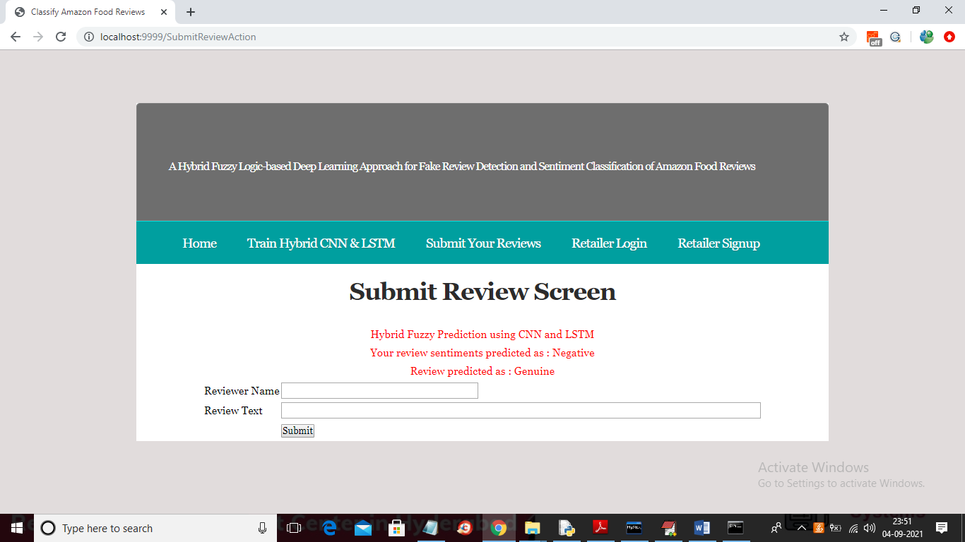

Now click on ‘Retailer Login’ and see all reviews details. In below screen retailer is login

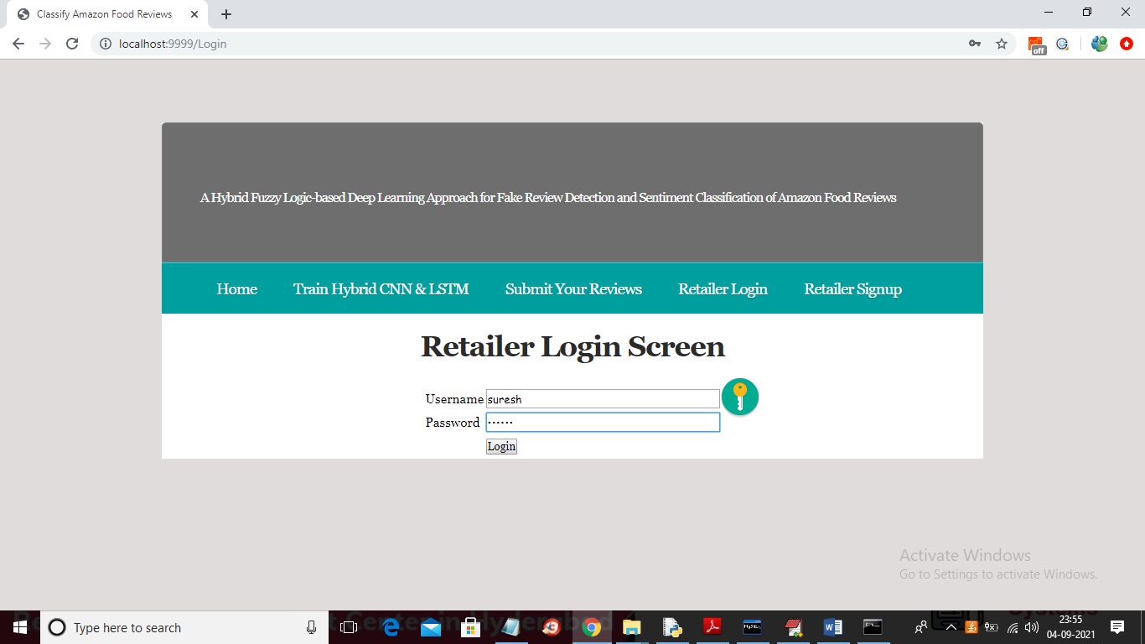

In above screen click on Login button to get below screen

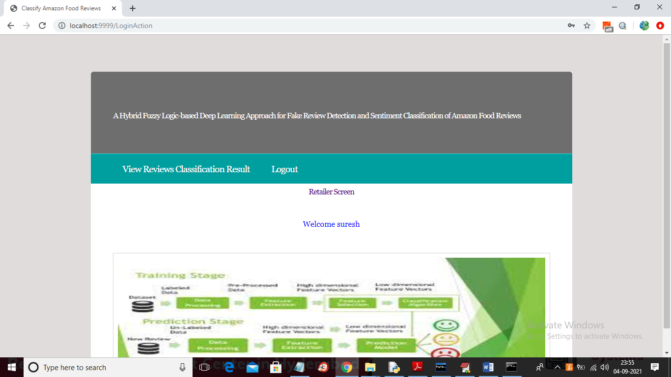

In above screen retailer can click on ‘View Reviews Classification Result’ link to get below output

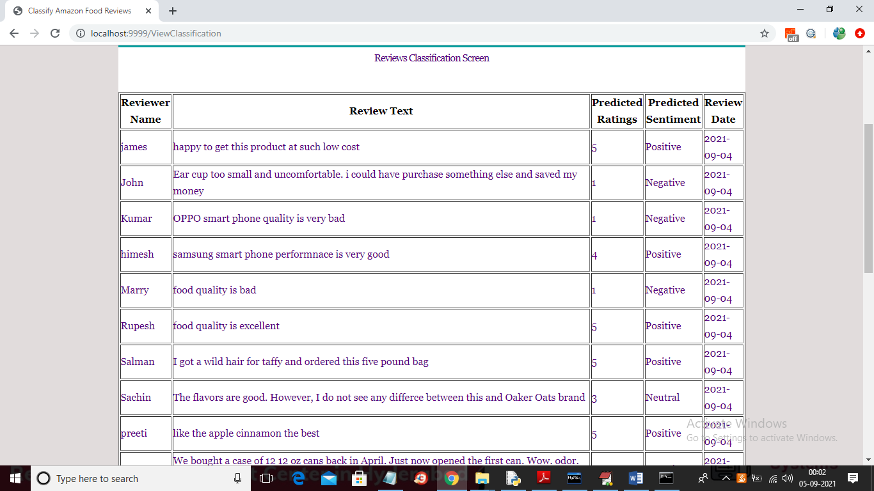

In above screen retailer can view all reviews and its sentiments and below is the sentiment graph

